|  |
| --- |
|  |
| 新概念 3 册 |
| Lesson56 |

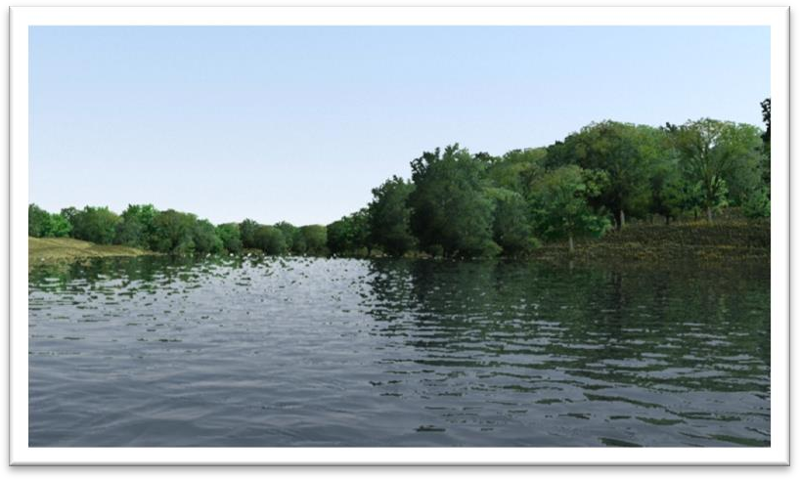Lesson 56 Our neighbor, the river

**boundary ['baʊndri]**

**n. 分界线，边界**

boundary n. dividing line 分界线，边界

The river forms a natural boundary of our farm.

The fence marks the boundary between my property and hers.

National boundaries are becoming increasingly meaningless in the global economy. Electronic publishing is blurring the boundaries between dictionaries and encyclopedias. border / frontier

the Italian border / frontier

the border / frontier between China and Russia

overtake [əʊvə'teɪk]

**v. （坏事）突然降临**

overtake overtook overtaken A sudden illness overtook him.

visit / befall (befell befallen)

A sudden illness visited / befell him. happen to

A sudden illness happened to him.

predecessor ['pri:disesə]

**n. 前辈，前任**

predecessor successor

ancestor forefather forebear descendant

He is a direct descendant of Confucius. offspring

the conflict between parents and their offspring posterity

These works of art are preserved for posterity.

meadow ['medəʊ]

**n. 草地；牧场**

meadow awn

pasture prairie

savanna(h) grassland the Inner Mongolian Grassland **occurrence [ə'kʌrəns]**

n. 事情，事件

occurrence occur

happening happen

trifle incident

a border incident

a shooting incident affair

current affairs

China’s internal affairs love affairs

event

accident / contingency coincidence **proportion [prə'pɔ:ʃn]**

n. 比例

the proportion of sth. to sth.

What's the proportion of boys to girls in your class? in proportion to sth.

Payment will be in proportion to the work done, not to the time spent doing it. out of (all) proportion to sth.

They earn salaries out of all proportion to their ability. a high / large proportion of …

a small / tiny proportion of … a high / large percentage of ... a small / tiny percentage of ... a / the majority of ...

a / the minority of ...

site [saɪt]

**v. 使位于**

site locate situate The house is sited / located / situated on the hill.

site location situation

juncture ['dʒʌŋktʃə(r)]

**n. 时刻，关头**

At this juncture it’s too late to say anything.

The battle had reached a critical / crucial juncture.

time moment

point instant

unduly [ʌn'dju:li]

**adv. 过分地，过度地**

unduly = excessively adv. 过分地，过度地

The levels of pollution in this area are unduly high. He did not sound unduly worried at the prospect. undue = excessive adj. 过分的，过度的

The work should be carried out without undue delay. We did not want to put any undue pressure on them. due adj. proper, suitable 适当的

After due consideration, we have decided to appoint Mr. Davis to the job.

submerge [səb'mɜ:dʒ]

**v. 淹没，潜入水中**

submerge submarine

dive diver / frogman

plunge into ...

go down / go under / go to the bottom

The tragic sinking of this great liner will always be remembered, for she went down on her first voyage with heavy loss of life.

man’s best friend, the dog God Almighty, Jesus Christ

The river which forms the eastern boundary of our farm has always played an important part in our lives.

play a … role / part in … 发挥某种作用

造句：西安市在中国历史上有至关重要的作用。

The city of Xi’an played a crucial role in the history of China.

造句：政府在促进人权方面应该发挥更显著的作用。

The government should play a more prominent part in promoting human rights.

Not all sounds made by animals serve as language, and we have only to turn to that extraordinary discovery of echo-location in bats to see a case in which the voice plays a strictly utilitarian role. The fact of first-rate importance is the predominant role that custom plays in experience and in belief, and the very great varieties it may manifest.

John Dewey has said in all seriousness that the part played by custom in shaping the behavior of the individual, as against any way in which he can affect traditional custom, is as the proportion of the total vocabulary of his mother tongue against those words of his own baby talk that are taken up into the vernacular of his family.

If we didn’t have it we could not make a living.

If + S. + did / were …, S. + would / should / could / might + do … There *would* be no living things without air.

There *would* be no living things if there *were* no air. In his position, I *would* commit suicide.

If I *were* in his position, I *would* commit suicide. make / earn a living

Be quiet or you’ll wake the house.

the village the town the city

the country the world

entertain the world

The whole country *was / were* shocked at the news.

... we have to pump from the river for irrigation.

... we have to pump from the river to irrigate the fields.

We know instinctively, *just as beekeepers with their bees*, that misfortune *might* overtake us if the important events of our lives *were* not related to it.

instinctively = by instinct particularly = in particular accidentally = by accident carefully = with care delightedly = with delight angrily = with anger

... misfortune might visit / befall us ...

... misfortune might happen to us ... relate sth. to sb.

She related the events of the previous week to the police. relate A to / with B

report / recount / relate sth. to sb. tell sb. (about) sth.

Sometimes we go upstream to a favourite backwater, sometimes we have our party at the boathouse, which a predecessor of ours at the farm built in the meadow *hard by the deepest pool for swimming and diving*.

go / row / sail upstream

Learning is like rowing upstream: not to advance is to drop back. go / row / sail downstream

a predecessor of ours one of our predecessors

hard by … (fml.) very near to …

The cafeteria stands hard by our dormitory. heat wave 酷暑时期

cold spell 严寒时期

It’s a boiling / scorching / sizzling hot day. It’s a bitterly / biting / freezing cold day.

We welcome the seasons by the riverside, crowning the youngest girl with flowers *in the spring*, holding a summer festival *on Midsummer Eve*, giving thanks for the harvest *in the autumn*, and throwing a holly wreath into the current *in the winter*.

We celebrate the arrival of the seasons. Mid-Autumn Festival

Dragon Boat Festival

Thanksgiving Day: the fourth Thursday in November the Puritans the Mayflower

Columbus

American Indians / Native Americans the Pilgrims

the Pilgrim Fathers

roast turkey apple pie

I give thanks to my mother for supporting me all the time. I give thanks to my math teacher for not flunking me.

This rarely / seldom occurs.

a rare / common / regular / everyday occurrence Laughter was a rare occurrence in his classroom.

Unfortunately, computer errors are a common occurrence. Street-fights are an everyday occurrence in this area of the city. go to extremes

Editors of newspapers and magazines often go to extremes to provide their readers with unimportant facts and statistics.

Our climate is usually moderate.

We are lucky in that only the lower fields, which make up a very small proportion of our farm, are affected by flooding, but other farms are less favourably sited, and flooding can sometimes spell disaster for their owners.

a high / large proportion / percentage of … a small / tiny proportion / percentage of … a majority of …

a vast / great / overwhelming majority of … a minority of …

a small / tiny minority of …

spell v. to cause sth. bad to happen in the future 招致，导致

spell disaster / trouble / danger for …

The lack of rain could spell disaster for farmers. This cold weather could spell trouble for gardeners. creep v. 蹑手蹑脚地走

Nevertheless, I managed to creep down into the living-room for two days before anyone found me out.

Curiosity swallowed him.

A gentle breeze caressed my cheeks and soothed my heart.

stall n. an enclosed area in a building for an animal such as a horse or cow 牲口棚，马厩，牛棚

stand to do sth: to be likely to do or have something 可能…… stand to gain / lose / win …

Many small companies stand to lose financially if the new law is introduced.

We were, *however*, worried about our nearest neighbours, whose farm was low lying and who were newcomers to the district.

The plane flew low. lowly adj. humble a lowly servant

put … out of order

put … in order put … right

When lights fuse, furniture gets rickety, pipes get clogged, or vacuum cleaners fail to operate, some women assume that their husbands will somehow put things right.

be out of order

The bell had been out of order for many years. put … out of business

put … out of work

I am out of patience.

I am out of anger.

The TV is out of repair. out of sympathy / pity out of interest

out of respect out of conscience out of necessity

out of desperation

So let us begin anew—remembering on both sides that civility is not a sign of weakness, and sincerity is always subject to proof. Let us never negotiate out of fear, but let us never fear to negotiate.

— John F. Kennedy

… find out how they were managing to deal with it.

*From an attic window* we could get a sweeping view of the river where their land joined ours, and

*at the most critical juncture* we took turns in watching that point.

… get a sweeping view

… get a bird's eye view

…, when the flood was at its height …

…, at the height of the flood … the height of ...

August is the height of summer. The storm is at its height.

take turns (in) doing sth. take turns to do sth.

There is only one computer, so we have to take turns (in) using it.

to use it.

sign indication omen a good omen

a bad omen

Next came a horse, *swimming bravely*, but we were afraid that the strength of the current would prevent its landing anywhere before it became exhausted.

全部倒装

把全部谓语置于主语之前。

1、表示位置或次序的状语置于句首，只要满足两个条件，要用全部倒装。①主语不是代词。

②谓语动词不是及物动词。

2、表语置于句首。Now *comes* your turn.

On the hill *stands* a temple.

Happy *is* he who has a sound mind in a sound body. Gone *are* the days when my heart was young and gay.

… prevent it from landing anywhere …

He always insisted on its being written out in full.

Suddenly a raft appeared, *looking rather like Noah's ark*, carrying the whole family, a few hens, the dogs, a cat, and a bird in a cage.

Noah’s ark the Genesis

the New Testament (Christians) the Old Testament (Jews) deluge

We realized that they must have become unduly frightened by the rising flood, *for their house, which had sound foundations, would have stood stoutly even if it had been almost submerged*. sound adj. in good condition and not damaged in any way 完好的

The floor was completely sound. Is the building structurally sound?

stout = sturdy adj. strong and thick 粗壮的，结实的

stout boots for climbing a stout walking-stick

The men of our family waded down through our flooded meadows *with boathooks*, in the hope of being able to grapple a corner of the raft and pull it out of the current towards our bank. wade

trek

in the hope of / that …

… in the hope that they would be able to …

Police are carrying out a house-to-house search in the hope of finding the missing girl.

The men of our family waded down through our flooded meadows with boathooks, in the hope of being *(=because they hope to be)* able to grapple a corner of the raft and pull it out of the current towards our bank.

The Swedes were the first to recognize that public officials like civil servants, police officers, health inspectors or tax-collectors can make mistakes or act over-zealously in the belief *(=because they believe)* that they are serving the public.

In the lift her thoughts were on lunch and a good rest; but when she got out at her own floor, both were forgotten in her sudden discovery *(=because she suddenly discovered)* that her front door was open.

They leave unwanted objects in drawers, cupboards and attics for years, in the belief that

*(=because they believe that)* they may one day need just those very things.

Young men who have reason to fear that they will be killed in battle may justifiably feel bitter in the thought *(=because they think)* that they have cheated of the best things that life has to offer. grapple v. to take a firm hold of sb./sth. and struggle with them 紧紧抓住，扭住，扭打

They managed to grapple him to the ground.

We still think it a miracle that they were able to do so.